Cari membri di NGV Italy,
Per vostra conoscenza, invio un video in inglese del Copenhagen Consensus Center che mostra come nel suo ciclo di vita i veicoli elettrici in realtà ne anche migliorano la performance sull’emissioni di CO2 di quelli a benzina:
https://www.prageru.com/courses/environmental-science/are-electric-cars-really-green

Gli autori:
The Copenhagen Consensus Center is a think tank that researches and publishes the smartest solutions for the world's biggest problems by cost-benefit. Its studies are conducted by more than 100 economists from internationally renowned institutions, including seven Nobel Laureates, to advise policy-makers and philanthropists how to spend their money most effectively.

Buon we a tutti,
Claudio Kohan
Alt Fuels Comm. Group Director
ckohan@altfuelscg.com
+39 335 189 3249

P.S.
Based on this video, Brad Couch, Ariel Compressors, wrote this:

Lifetime Carbon Emissions of EV's, CNG and Gasoline vehicles. CNG show best environmental performance!
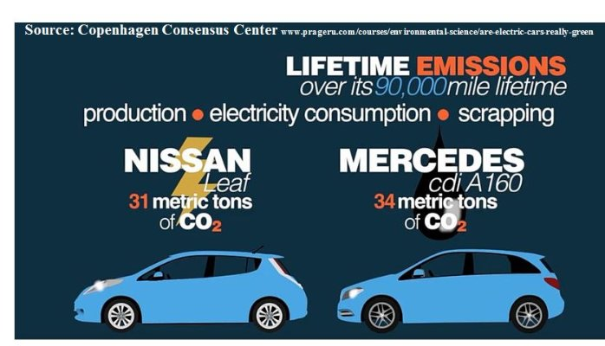
On a lifetime basis, BioCNG burning vehicles can achieve a 35% emissions reduction over electric vehicles and may push 50%.
According to research by the cited groups below, consider the following facts and assumptions:
Carbon emission to produce:
One EV vehicle 25,000 pounds of CO2*
One Gasoline vehicle 16,000 pounds of CO2*
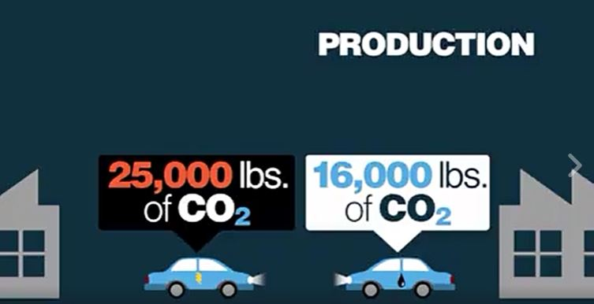
Lifetime carbon emissions for production, operation for 90,000 miles, and scrapping:
One EV vehicle 31,000 metric tons of CO2* (Tesla numbers slightly different, but not much on a percentage basis. Last illustration addresses this).
One Gasoline vehicle 34,000 metric tons of CO2*
When using BioCNG in transportation, well-to wheel greenhouse gas emissions can be reduced by
80% to 115% during operation**
Assumptions:
Using 80% reduction GHG reduction of a CNG burning vehicle compared to a gasoline is a meaningful comparison.
If a CNG vehicle is only burning BioCNG from landfill gas or other comparable sources produces a reduction of 115% GHG traditional liquid fuels.
The carbon emissions of a gasoline vehicle and similar CNG vehicle is roughly comparable
So according to the above, the carbon emissions to produce a CNG vehicle can be around 16,000 pounds. If the vehicle operates at a 115% reduction, it’s generated a -15% carbon credit annually.
Another way to look at this Carbon Footprint issue is on a daily CO2 production.
Gasoline burning vehicles product around 13 pounds of CO2 per day. While, recharged on the average electrical grid in USA EV’s product 7.5 pounds of CO2 per vehicle/day. ***
Bio CNG burning Natural Gas Vehicles (NGVs) product 1.5 pounds down to – 1.125 pounds**
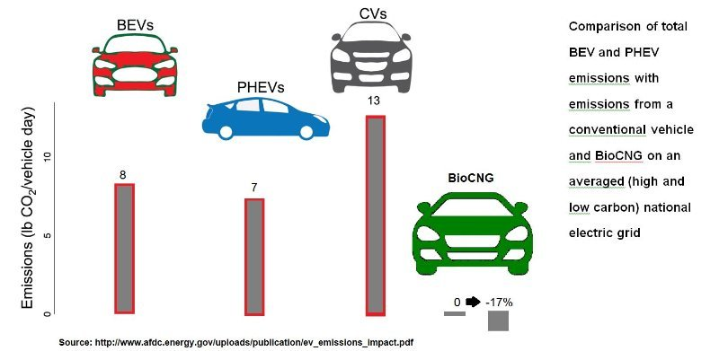

* Copenhagen Consensus Center www.prageru.com/courses/environmental-science/are-electric-cars-really-green
** NGVAmerica www.ngvamerica.org/wordpress/wp-content/uploads/2016/09/NGVAmerica-White-Paper-Fleets-Run-Cleaner-on-Natural-Gas_V2.pdf
*** US DOE Alternative Fuel Data Centerwww.afdc.energy.gov/uploads/publication/ev_emissions_impact.pdf

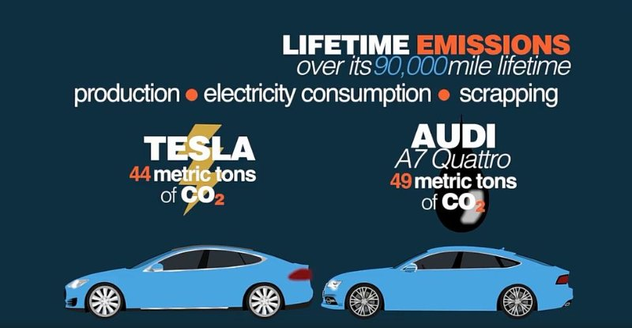This screen shot is from the Copenhagen Consensus Center research as well.

